# Le Corbusier

QUOTES

*"I prefer drawing to talking. Drawing is faster, and leaves less room for lies."*

– Le Corbusier

* **BIRTH DATE:** [October 06](http://www.biography.com/people/groups/born-on-october-06/), [1887](http://www.biography.com/people/groups/born-1887/)
* **DEATH DATE:** [August 27](http://www.biography.com/people/groups/died-on-august-27/), 1965
* **EDUCATION:** École des Arts Décoratifs at La Chaux-de-Fonds
* **PLACE OF BIRTH:** La Chaux-de-Fonds, Switzerland
* **PLACE OF DEATH:** Cap Martin, France

NATIONALITY: Swiss, French(from1930)

**Family**

Le Corbusier was born in Switzerland on October 6, 1887-August 27, 1965

Le Corbusier was the second son of Edouard Jeanneret , an artist who painted dials in the town’s renowned watch industry.

 And Madame Jeannerct-Perrct, a musician and piano teacher.

**History**

He was an architect, designer, painter, [urban planner](http://en.wikipedia.org/wiki/Urban_planner), writer, and one of the pioneers of what is now called [modern architecture](http://en.wikipedia.org/wiki/Modern_architecture).

He was born in [Switzerland](http://en.wikipedia.org/wiki/Switzerland) and became a [French citizen](http://en.wikipedia.org/wiki/France) in 1930.

His career spanned five decades, with his buildings constructed throughout Europe, India, and America.

In his architecture, he chiefly built with steel and reinforced concrete and worked with elemental geometric forms

**Education**

At age 13, Le Corbusier left primary school to attend Arts Décoratifs at La Chaux-de-Fonds

In 1906 he made his first trip outside of Switzerland, going to Italy. At around 1907, he travelled to Paris, where he found work in the office of[Auguste Perret](http://en.wikipedia.org/wiki/Auguste_Perret), the French pioneer of [reinforced concrete](http://en.wikipedia.org/wiki/Reinforced_concrete).

It was both his trip to Italy and his employment at Perret's office that began to form his own ideas about architecture. In 1908, he studied architecture in [Vienna](http://en.wikipedia.org/wiki/Vienna) with [Josef Hoffmann](http://en.wikipedia.org/wiki/Josef_Hoffmann).

Between October 1910 and March 1911, he worked near [Berlin](http://en.wikipedia.org/wiki/Berlin) for the renowned architect [Peter Behrens](http://en.wikipedia.org/wiki/Peter_Behrens), where he may have met [Ludwig Mies van der Rohe](http://en.wikipedia.org/wiki/Ludwig_Mies_van_der_Rohe) and[Walter Gropius](http://en.wikipedia.org/wiki/Walter_Gropius).

He became fluent in German. More than anything during this period, it was his visit to the Charterhouse of the Valley of Ema that influenced his architectural philosophy profoundly for the rest of his life.

He believed that all people should have the opportunity to live as beautifully and peacefully as the monks he witnessed in the sanctuaries at the charterhouse.

Later in 1911, he journeyed to the [Balkans](http://en.wikipedia.org/wiki/Balkans) and visited [Bulgaria](http://en.wikipedia.org/wiki/Bulgaria), [Greece](http://en.wikipedia.org/wiki/Greece), and [Turkey](http://en.wikipedia.org/wiki/Turkey), filling nearly 80 sketchbooks with renderings of what he saw—including many sketches of the [Parthenon](http://en.wikipedia.org/wiki/Parthenon),

After designing his first house, in 1907, at age 20, Le Corbusier took trips through central Europe and the Mediterranean, including Italy, Vienna, Munich and Paris.

**Currency**

|  |  |  |  |  |  |  |  |
| --- | --- | --- | --- | --- | --- | --- | --- |
| **8th (current) series of Swiss banknotes**[[13]](http://en.wikipedia.org/wiki/Banknotes_of_the_Swiss_franc#cite_note-13) | | | | | | | |
|  | | **Value** | **Dimensions** | **Main Colour** | **Obverse** | **Date of issue** |  |
| **Obverse** |  |
| [CHF10 8 front horizontal.jpg](http://en.wikipedia.org/wiki/File:CHF10_8_front_horizontal.jpg) |  | 10 francs | 126 × 74 mm | Yellow | [Le Corbusier](http://en.wikipedia.org/wiki/Le_Corbusier) | 8 April 1997 |  |

## Urbanism

For a number of years, French officials had been unsuccessful in dealing with the squalor of the growing Parisian slums, and Le Corbusier sought efficient ways to house large numbers of people in response to the urban housing crisis. He believed that his new, modern architectural forms would provide an organizational solution that would raise the quality of life for the lower classes. His Immeubles Villas (1922) was such a project, calling for large blocks of cell-like individual apartments stacked one on top of one another, with plans that included a living room, bedrooms, and kitchen, as well as a garden terrace.

## Death

Against his doctor's orders, on August 27, 1965, Le Corbusier went for a swim in the[Mediterranean Sea](http://en.wikipedia.org/wiki/Mediterranean_Sea) at [Roquebrune-Cap-Martin](http://en.wikipedia.org/wiki/Roquebrune-Cap-Martin), France. His body was found by bathers and he was pronounced dead at 11 a.m. It was assumed that he may have suffered a heart attack. His death rites took place at the courtyard of the [Louvre](http://en.wikipedia.org/wiki/Louvre) Palace on September 1, 1965

**Awards**

He was awarded the [Frank P. Brown Medal](http://en.wikipedia.org/wiki/The_Franklin_Institute_Awards) and [AIA Gold Medal](http://en.wikipedia.org/wiki/AIA_Gold_Medal) in 1961.

**Memorials**

Le Corbusier's portrait was featured on the [10 Swiss francs banknote](http://en.wikipedia.org/wiki/Banknotes_of_the_Swiss_franc#Eighth_series), pictured with his distinctive eyeglasses.

The following place-names carry his name:

* Place Le Corbusier, Paris, near the site of his [*atelier*](http://en.wiktionary.org/wiki/atelier) on the Rue de Sèvres.
* Le Corbusier Boulevard, [Laval, Quebec](http://en.wikipedia.org/wiki/Laval,_Quebec), Canada.
* Place Le Corbusier in his hometown of [La Chaux-de-Fonds](http://en.wikipedia.org/wiki/La_Chaux-de-Fonds), Switzerland.
* Le Corbusier Street in the [*partido*](http://en.wikipedia.org/wiki/Partido) of [Malvinas Argentinas](http://en.wikipedia.org/wiki/Malvinas_Argentinas), [Buenos Aires Province](http://en.wikipedia.org/wiki/Buenos_Aires_Province), Argentina.
* Le Corbusier Street in *Le Village Parisien* of [Brossard, Quebec](http://en.wikipedia.org/wiki/Brossard,_Quebec), Canada.
* Le Corbusier Promenade, a promenade along the water at Roquebrune-Cap-Martin.
* Le Corbusier Museum, Sector- 8 [Chandigarh](http://en.wikipedia.org/wiki/Chandigarh), India.

## Works

*Main article:*[*List of Le Corbusier buildings*](http://en.wikipedia.org/wiki/List_of_Le_Corbusier_buildings)

[Church of Saint-Pierre](http://en.wikipedia.org/wiki/Saint-Pierre,_Firminy), [Firminy](http://en.wikipedia.org/wiki/Firminy), France

* 1923: [Villa La Roche](http://en.wikipedia.org/wiki/Villa_La_Roche), Paris
* 1925: [Villa Jeanneret](http://en.wikipedia.org/wiki/Villa_Jeanneret), Paris
* 1928: [Villa Savoye](http://en.wikipedia.org/wiki/Villa_Savoye), [Poissy-sur-Seine](http://en.wikipedia.org/wiki/Poissy-sur-Seine), France
* 1929: [Cité du Refuge](http://en.wikipedia.org/w/index.php?title=Cit%C3%A9_du_Refuge&action=edit&redlink=1), [Armée du Salut](http://en.wikipedia.org/wiki/Arm%C3%A9e_du_Salut), Paris, France
* 1931: [Palace of the Soviets](http://en.wikipedia.org/wiki/Palace_of_the_Soviets), Moscow, [USSR](http://en.wikipedia.org/wiki/Soviet_Union) (project)
* 1931: [Immeuble Clarté](http://en.wikipedia.org/wiki/Immeuble_Clart%C3%A9), Geneva, Switzerland
* 1933: [Tsentrosoyuz](http://en.wikipedia.org/wiki/Tsentrosoyuz), Moscow, USSR
* 1947–1952: [Unité d'Habitation](http://en.wikipedia.org/wiki/Unit%C3%A9_d%27Habitation), [Marseille](http://en.wikipedia.org/wiki/Marseille), France
* 1949–1952: [United Nations headquarters](http://en.wikipedia.org/wiki/United_Nations_headquarters), New York City (Consultant)
* 1949-1953: [Curutchet House](http://en.wikipedia.org/wiki/Curutchet_House), [La Plata](http://en.wikipedia.org/wiki/La_Plata), Argentina (project manager: [Amancio Williams](http://en.wikipedia.org/wiki/Amancio_Williams) )
* 1950–1954: Chapelle [Notre Dame du Haut](http://en.wikipedia.org/wiki/Notre_Dame_du_Haut), Ronchamp, France
* 1951: [Maisons Jaoul](http://en.wikipedia.org/wiki/Maisons_Jaoul), [Neuilly-sur-Seine](http://en.wikipedia.org/wiki/Neuilly-sur-Seine), France
* 1951: Buildings in [Ahmedabad](http://en.wikipedia.org/wiki/Ahmedabad), India
  + 1951: [Sanskar Kendra](http://en.wikipedia.org/wiki/Sanskar_Kendra) Museum, Ahmedabad
  + 1951: [ATMA House](http://en.wikipedia.org/wiki/ATMA_House)
  + 1951: [Villa Sarabhai](http://en.wikipedia.org/wiki/Villa_Sarabhai), Ahmedabad
  + 1951: [Villa Shodhan](http://en.wikipedia.org/wiki/Villa_Shodhan), Ahmedabad
* 1952: Unité d'Habitation of Nantes-Rezé, [Nantes](http://en.wikipedia.org/wiki/Nantes), France
* 1952–1959: Buildings in [Chandigarh](http://en.wikipedia.org/wiki/Chandigarh), India
  + 1952: [Palace of Justice](http://en.wikipedia.org/wiki/Punjab_and_Haryana_High_Court)
  + 1952: [Museum and Gallery of Art](http://en.wikipedia.org/wiki/Government_Museum_and_Art_Gallery,_Chandigarh)
  + 1953: [Secretariat Building](http://en.wikipedia.org/wiki/Secretariat_Building_(Chandigarh))
  + 1953: [Governor's Palace](http://en.wikipedia.org/wiki/Governor%27s_Palace_(Chandigarh))
  + 1955: [Palace of Assembly](http://en.wikipedia.org/wiki/Palace_of_Assembly_(Chandigarh))
  + 1959: Government College of Art (GCA) and the [Chandigarh College of Architecture](http://en.wikipedia.org/wiki/Chandigarh_College_of_Architecture)(CCA)
* 1957: [Maison du Brésil](http://en.wikipedia.org/wiki/Maison_du_Br%C3%A9sil), [Cité Universitaire](http://en.wikipedia.org/wiki/Cit%C3%A9_Internationale_Universitaire_de_Paris), Paris
* 1957–1960: [Sainte Marie de La Tourette](http://en.wikipedia.org/wiki/Sainte_Marie_de_La_Tourette), near [Lyon](http://en.wikipedia.org/wiki/Lyon), France (with Iannis Xenakis)
* 1957: [Unité d'Habitation of Berlin](http://en.wikipedia.org/wiki/Unit%C3%A9_d%27Habitation_of_Berlin)-Charlottenburg, Flatowallee 16, Berlin
* 1964–1969: [Firminy-Vert](http://en.wikipedia.org/wiki/Patrimoine_Le_Corbusier_de_Firminy-Vert)
  + 1964: [Unité d'Habitation of Firminy](http://en.wikipedia.org/w/index.php?title=Unit%C3%A9_d%27Habitation_of_Firminy&action=edit&redlink=1), France
  + 1965: [Maison de la culture de Firminy-Vert](http://en.wikipedia.org/w/index.php?title=Maison_de_la_culture_de_Firminy-Vert&action=edit&redlink=1)
* 1967: [Heidi Weber Museum](http://en.wikipedia.org/wiki/Heidi_Weber_Museum) (Centre Le Corbusier), Zurich, Switzerland

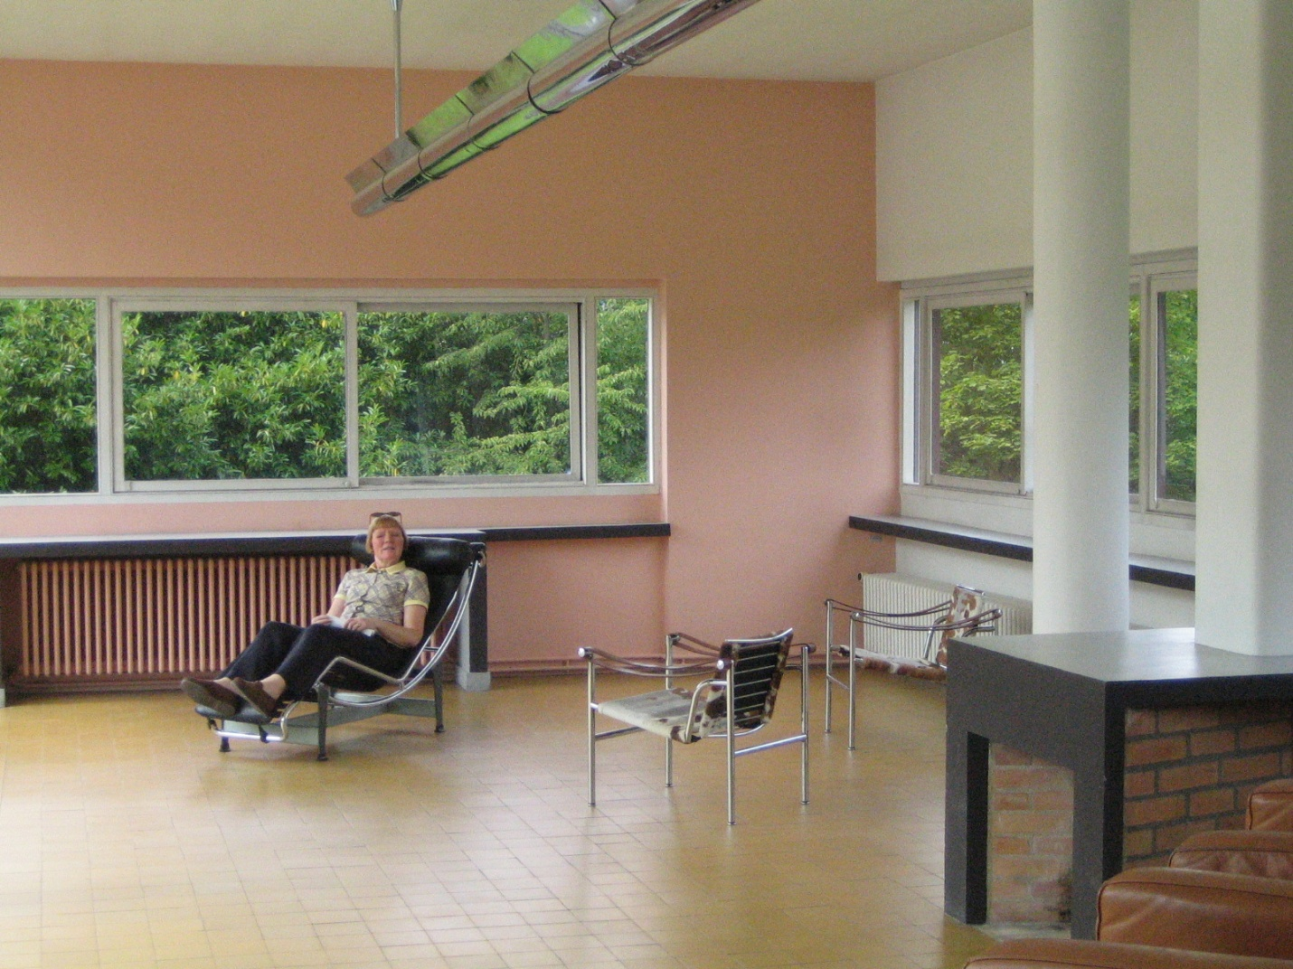

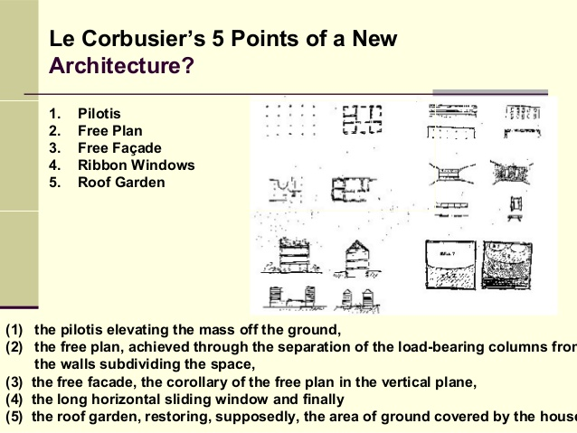

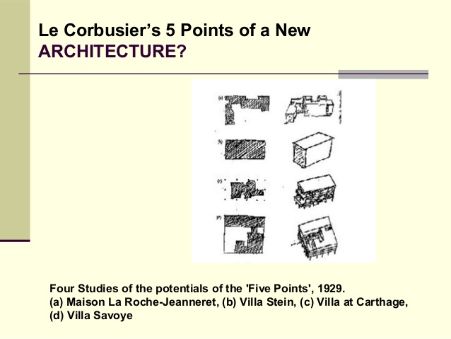

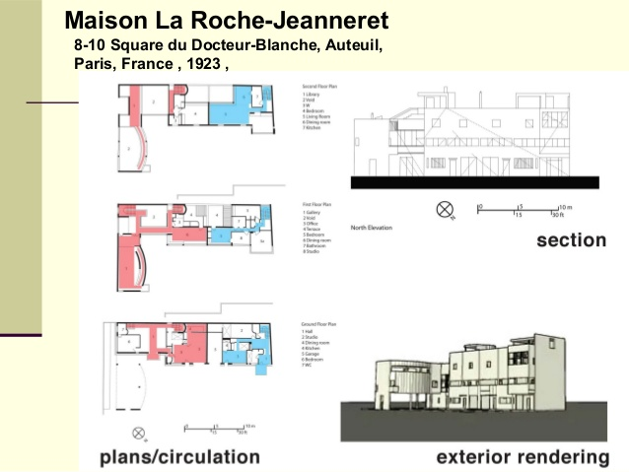

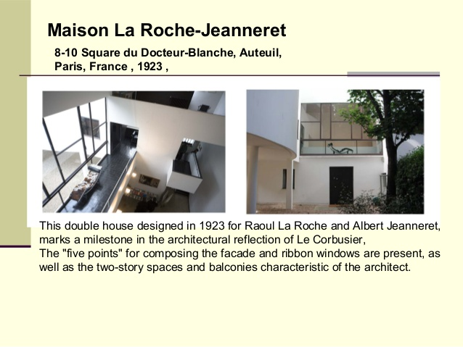

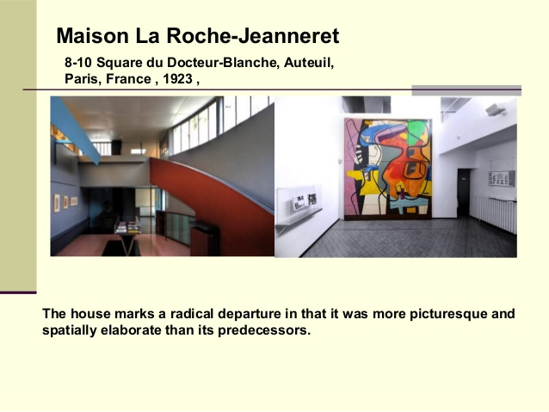

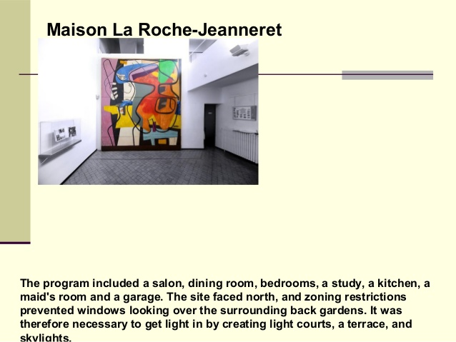

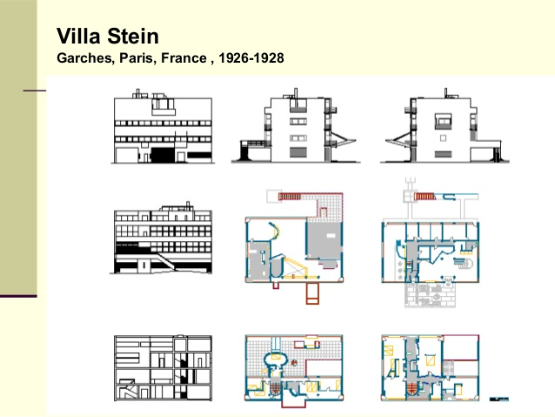

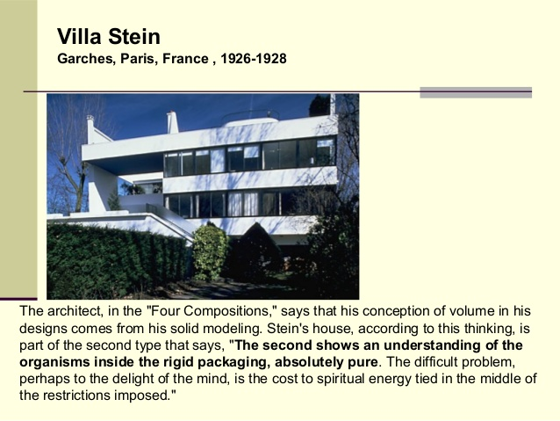

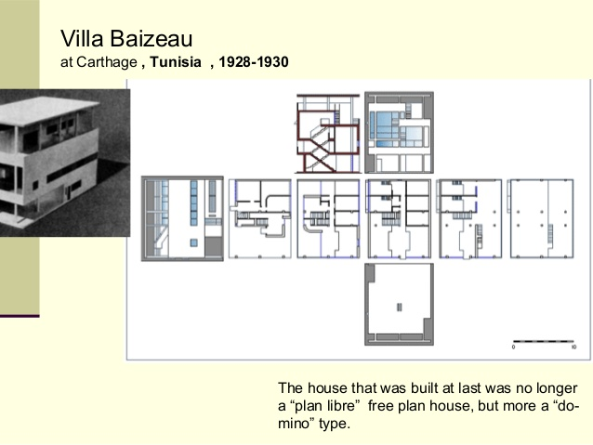

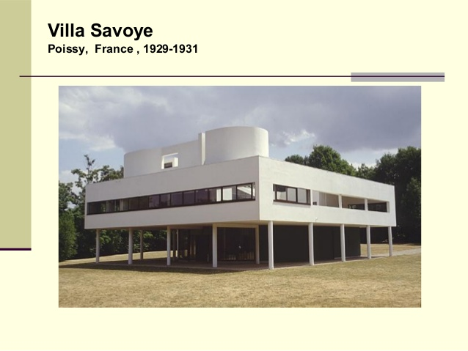

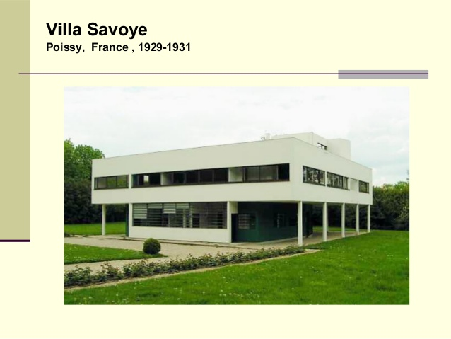

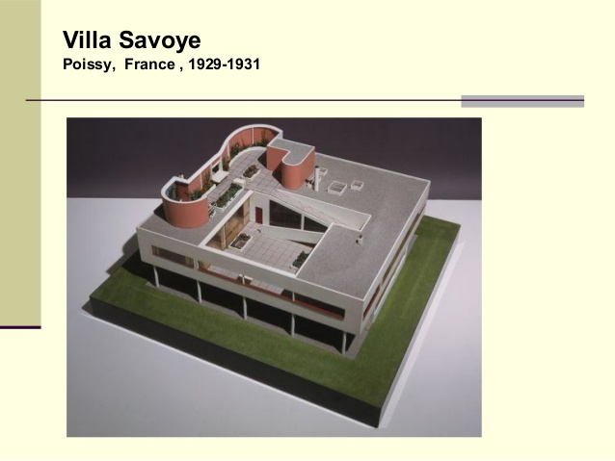

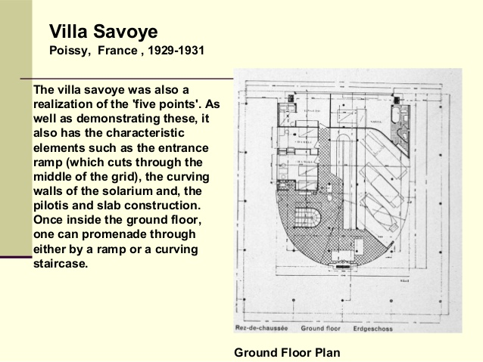

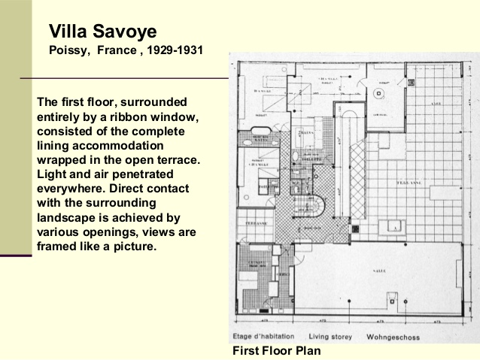

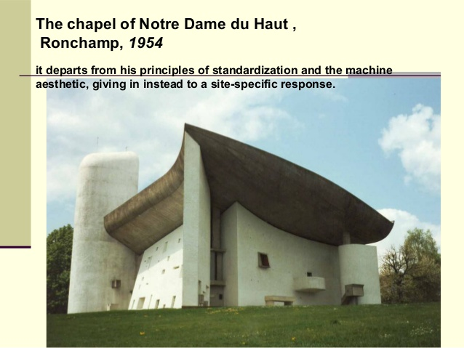

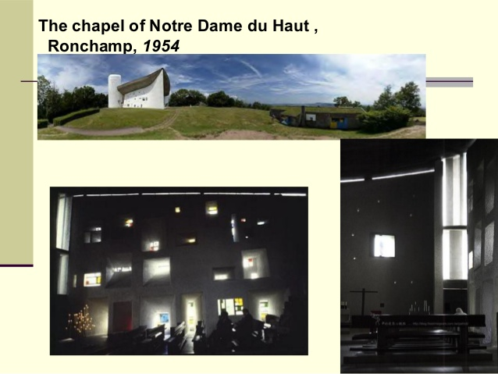

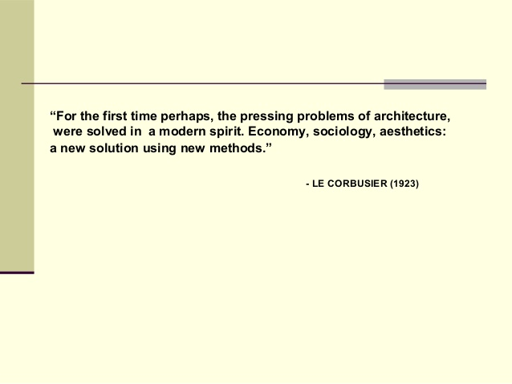

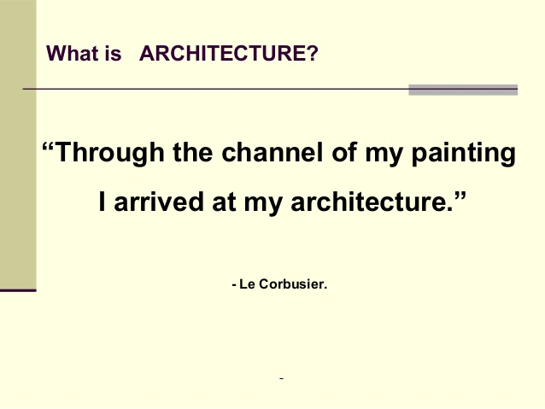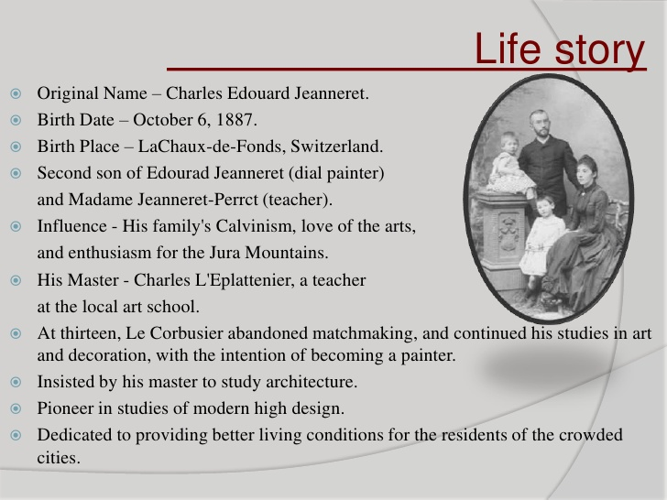

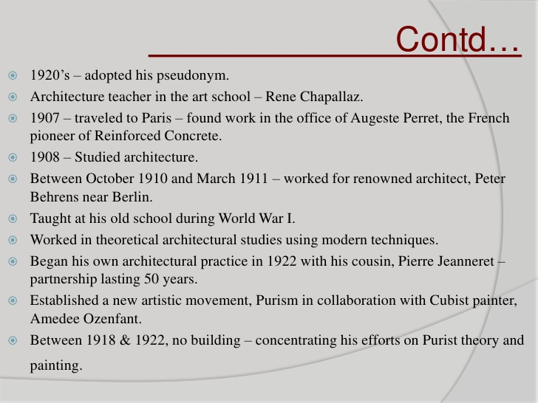

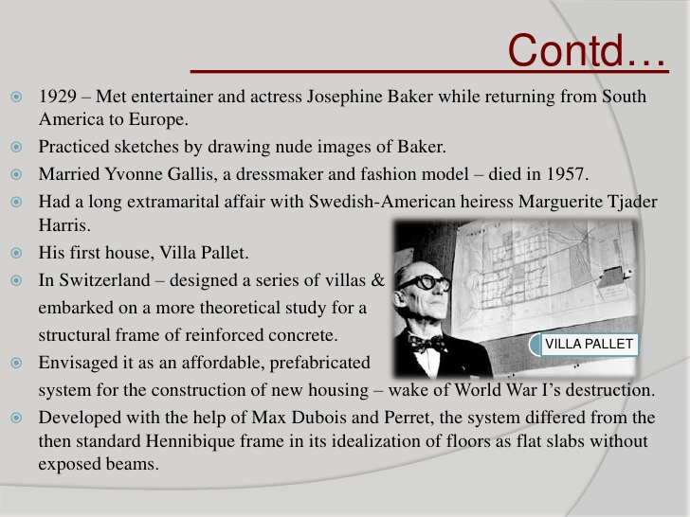

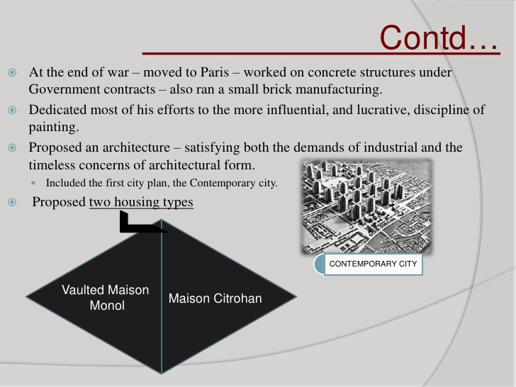

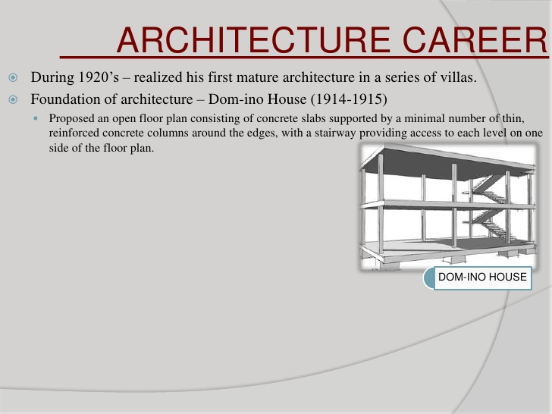

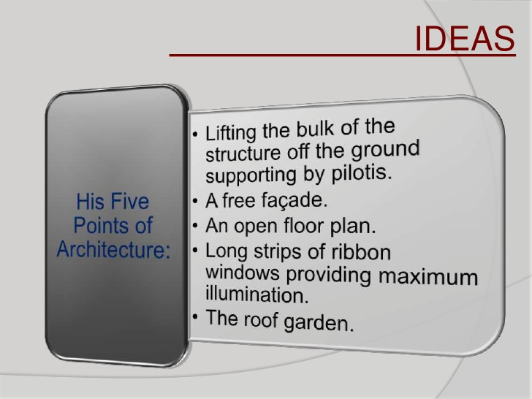

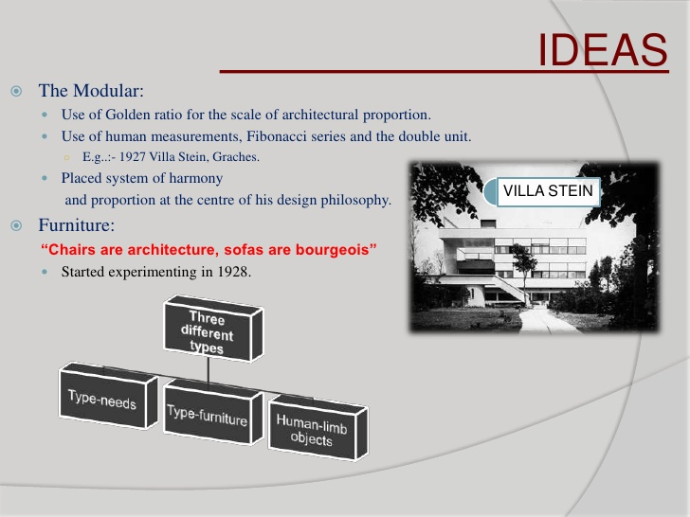

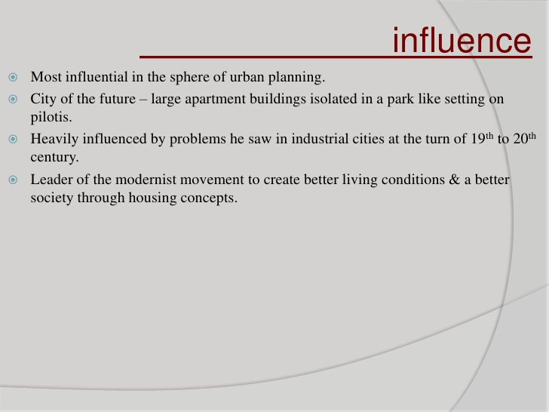

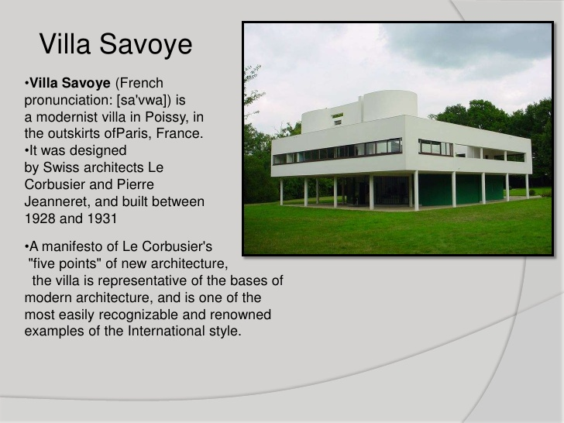

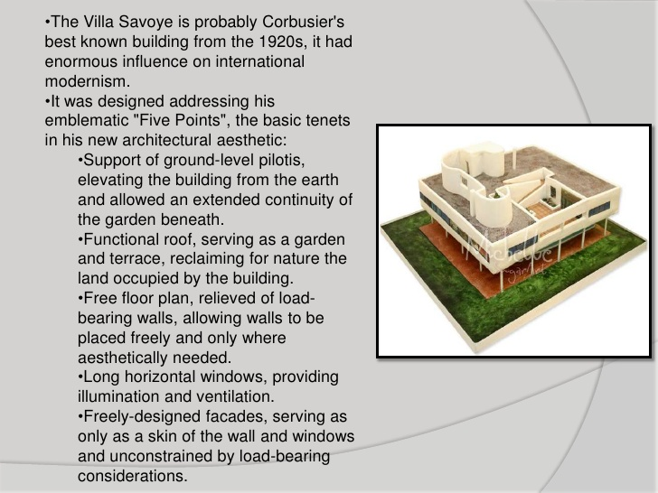

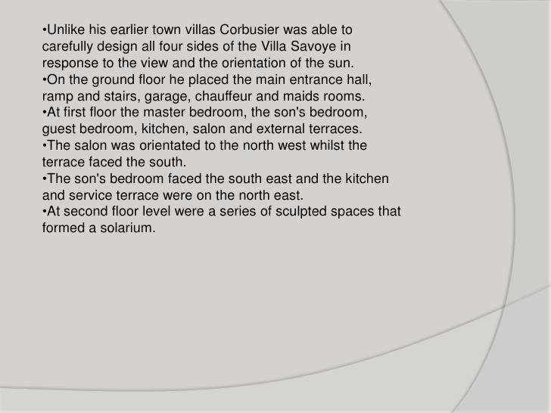

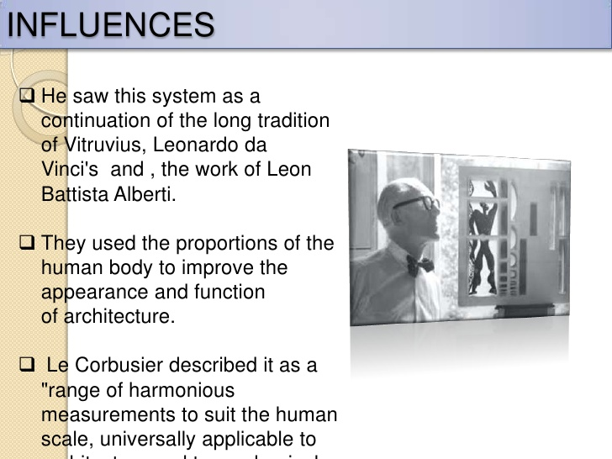

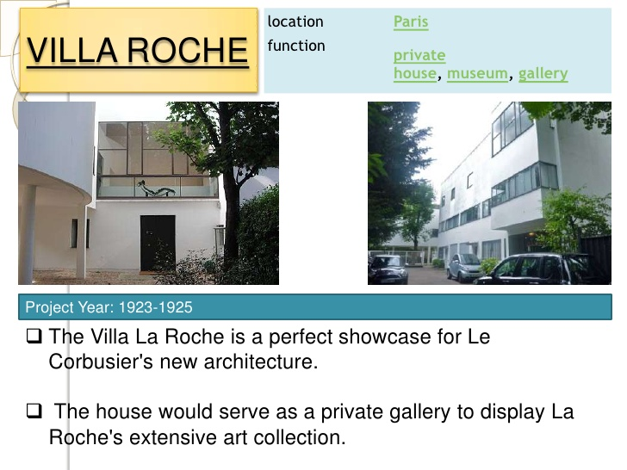

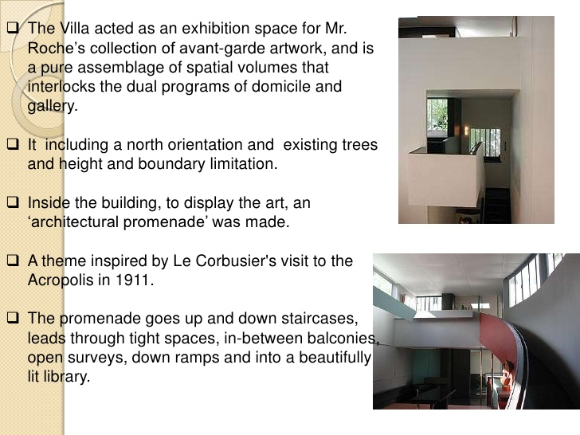

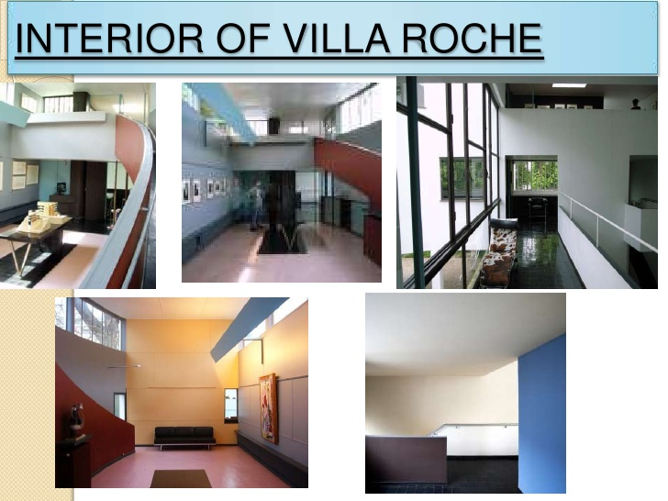

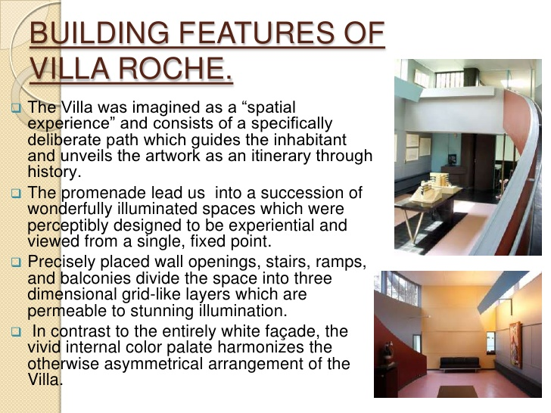

|  |  |
| --- | --- |
| **Villa Savoye** | |
| [VillaSavoye.jpg](http://en.wikipedia.org/wiki/File:VillaSavoye.jpg)  View of the west and south facades of the villa. | |
| **General information** | |
| **Type** | Villa |
| **Architectural style** | [Modernist](http://en.wikipedia.org/wiki/Modern_architecture), [International](http://en.wikipedia.org/wiki/International_style_(architecture)) |
| **Address** | 82, Rue de Villiers  78300 Poissy |
| **Town or city** | [Poissy](http://en.wikipedia.org/wiki/Poissy), [Yvelines](http://en.wikipedia.org/wiki/Yvelines) |
| **Country** | [France](http://en.wikipedia.org/wiki/France) |
| [**Coordinates**](http://en.wikipedia.org/wiki/Geographic_coordinate_system) | http://upload.wikimedia.org/wikipedia/commons/thumb/5/55/WMA_button2b.png/17px-WMA_button2b.png[48°55′28″N 2°1′42″E](http://tools.wmflabs.org/geohack/geohack.php?pagename=Villa_Savoye&params=48_55_28_N_2_1_42_E_type:landmark_region:FR) |
| **Current tenants** | [Centre des monuments nationaux](http://en.wikipedia.org/wiki/Centre_des_monuments_nationaux) |
| **Construction started** | 1928 |
| **Completed** | 1931 |
| **Renovated** | 1963, 1985-1997 |
| **Owner** | [French government](http://en.wikipedia.org/wiki/French_government) |
| **Technical details** | |
| **Structural system** | [Reinforced concrete](http://en.wikipedia.org/wiki/Reinforced_concrete) |
| **Design and construction** | |
| **Architect** | [Le Corbusier](http://en.wikipedia.org/wiki/Le_Corbusier), [Pierre Jeanneret](http://en.wikipedia.org/wiki/Pierre_Jeanneret) |

villa savoye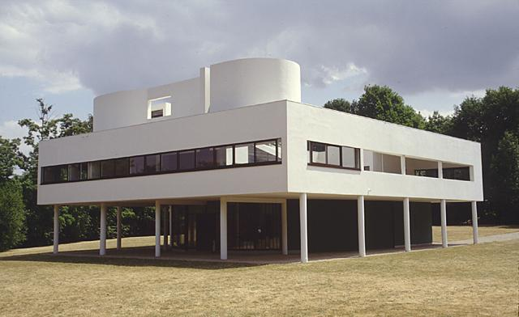

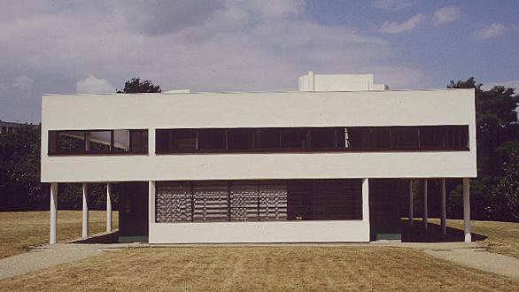

Ground floor

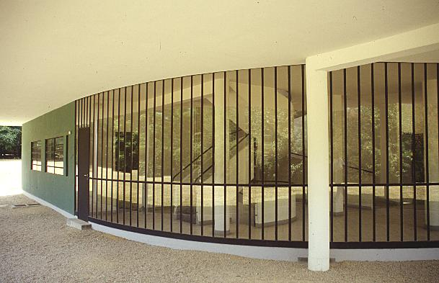

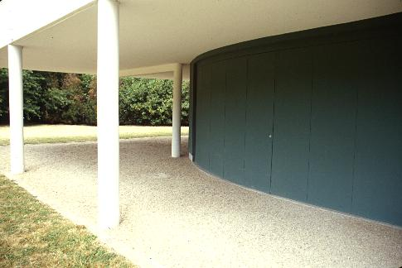

Spiral staricase

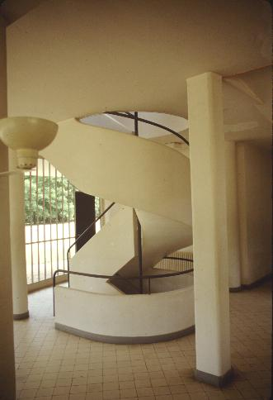

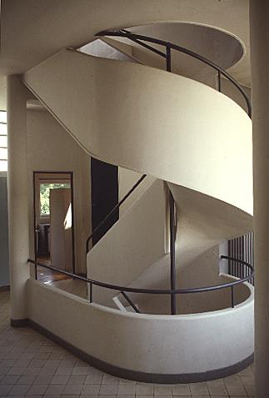

Ramp to roof garden

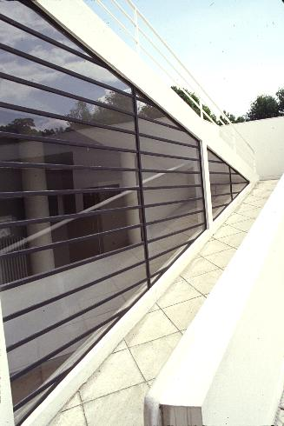

Roof Garden

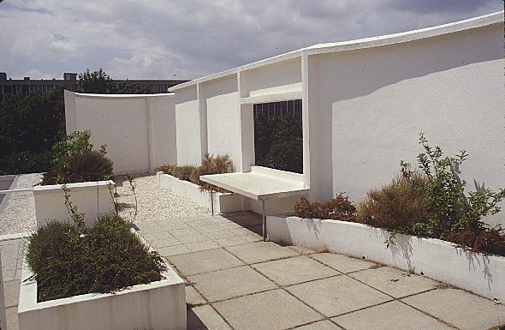

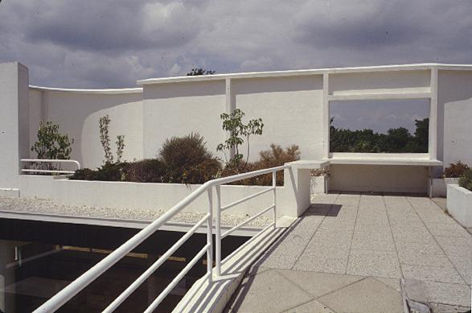

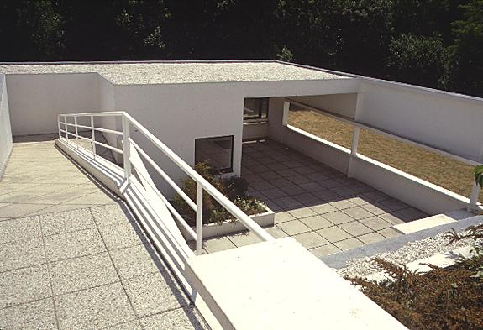

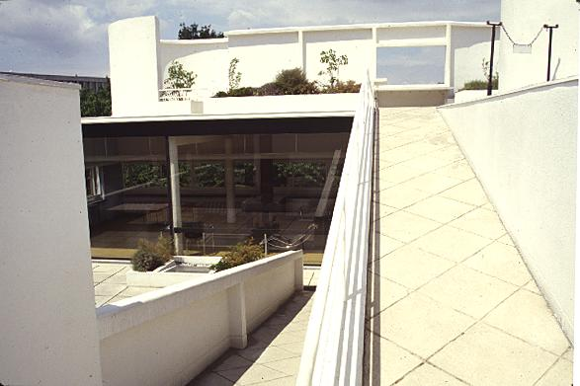

Interior Ramp

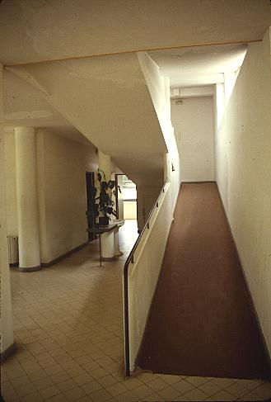

Interior

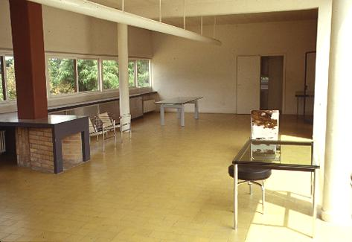

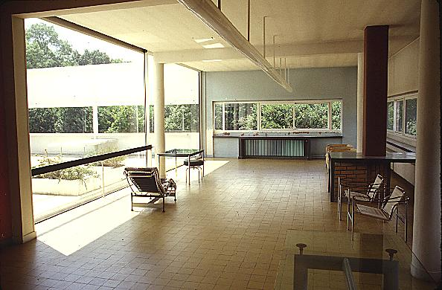

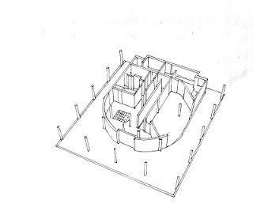

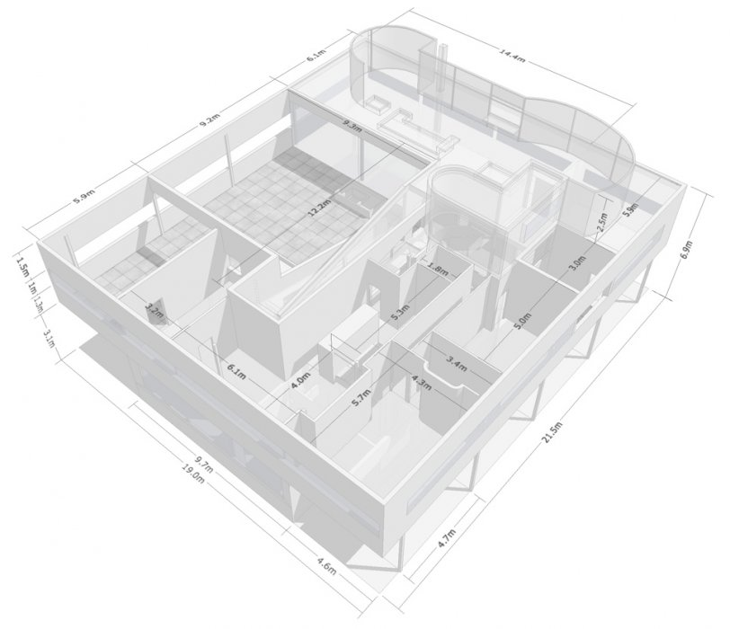

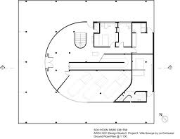

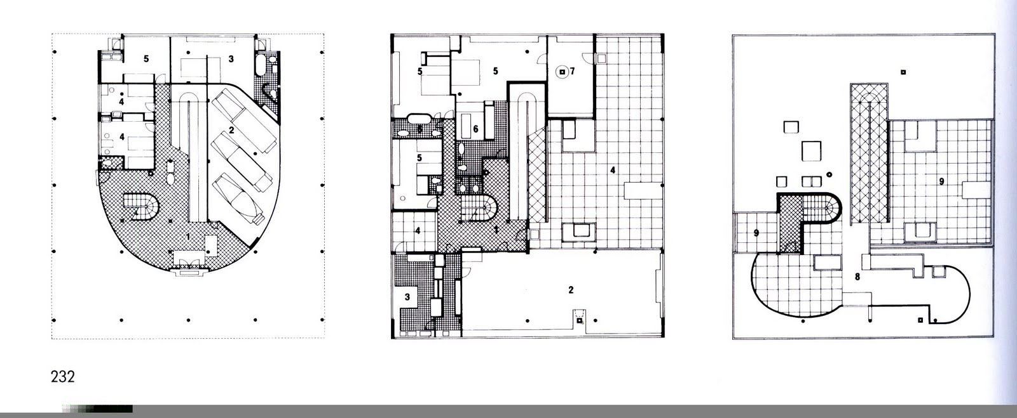

|  |  |
| --- | --- |
| [RonchampCorbu.jpg](http://en.wikipedia.org/wiki/File:RonchampCorbu.jpg) | |
| **Basic information** | |
| **Location** | [Ronchamp](http://en.wikipedia.org/wiki/Ronchamp), [Haute-Saône](http://en.wikipedia.org/wiki/Haute-Sa%C3%B4ne),[France](http://en.wikipedia.org/wiki/France) |
| [**Geographic coordinates**](http://en.wikipedia.org/wiki/Geographic_coordinate_system) | http://upload.wikimedia.org/wikipedia/commons/thumb/5/55/WMA_button2b.png/17px-WMA_button2b.png[47°42′16.37″N6°37′14.08″E](http://tools.wmflabs.org/geohack/geohack.php?pagename=Notre_Dame_du_Haut&params=47_42_16.37_N_6_37_14.08_E_type:landmark_scale:1000_region:FR)[Coordinates](http://en.wikipedia.org/wiki/Geographic_coordinate_system): http://upload.wikimedia.org/wikipedia/commons/thumb/5/55/WMA_button2b.png/17px-WMA_button2b.png[47°42′16.37″N 6°37′14.08″E](http://tools.wmflabs.org/geohack/geohack.php?pagename=Notre_Dame_du_Haut&params=47_42_16.37_N_6_37_14.08_E_type:landmark_scale:1000_region:FR) |
| [**Affiliation**](http://en.wikipedia.org/wiki/List_of_religions_and_spiritual_traditions) | [Roman Catholic](http://en.wikipedia.org/wiki/Roman_Catholic) |
| **Year consecrated** | 25 june 1955 |
| [**Ecclesiastical or organizational status**](http://en.wikipedia.org/wiki/Ecclesiastical_polity) | Pilgrimage Chapel |
| **Website** | [www.chapellederonchamp.fr](http://www.chapellederonchamp.fr/) |
| **Architectural description** | |
| [**Architect**](http://en.wikipedia.org/wiki/Architect)**(s)** | [Le Corbusier](http://en.wikipedia.org/wiki/Le_Corbusier) |
| **Architectural type** | [Chapel](http://en.wikipedia.org/wiki/Chapel) |
| **Groundbreaking** | 1953 |
| **Completed** | 1955 |
| **Specifications** | |
| [**Materials**](http://en.wikipedia.org/wiki/Building_material) | Concrete |
| [**Monument historique**](http://en.wikipedia.org/wiki/Monument_historique) | |
| *Official name: Chapelle Notre-Dame-du-Haut* | |
| **Designated:** | 1967 |
| **Reference No.** | PA00102263[[1]](http://en.wikipedia.org/wiki/Notre_Dame_du_Haut#cite_note-1) |
| **Denomination:** | Chapelle |

